UNIT12
DON’T RIDE YOUR BIKE TOO FAST
I. Listen and match
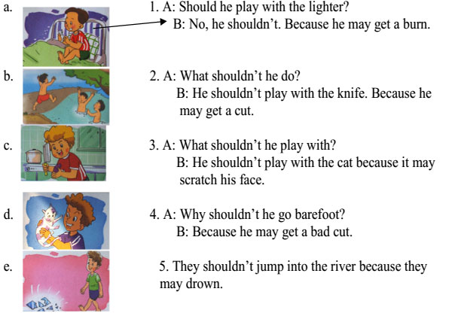
II. Listen and tick A, B or C. There is one example.
Example: | A. I want to sleep at night.
 | B. I want to cut the apple.
 | C. I want to go to bed early.

1. A. I’m chatting with them.
B. I’m going to eat them.
C. I’m giving them to Mum.
2. A. OK, I won’t.
B. OK, I don’t.
C. OK, I will.
3. A. Because you should keep warm.
B. Because you should brush your teeth.
C. Because you may fall and break your leg.
4. A. She may fall off her bike.
B. She may cut herself.
C. She may get a burn.
5. A. Because you may fall down.
B. Because you may get a fever.
C. Because you may get a burn.
III.Fill in the blank with suitable word.
- What is she__________?she is__________a cabbage.
- Don’t play with a _________. You may cut yourself.
- He shouldn’t climb the tree because he may ____________and break his leg.
- They are ________________the tree. They may fall.
- Don’t __________the stove. You may get a burn.

