UNIT 17
WHAT WOULD YOU LIKE TO EAT?
I.Listen and tick.
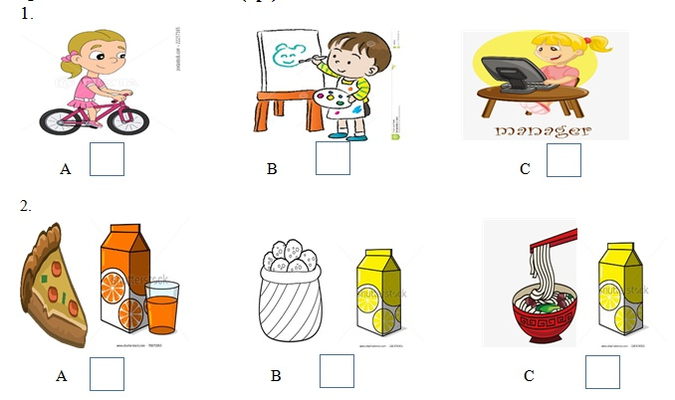
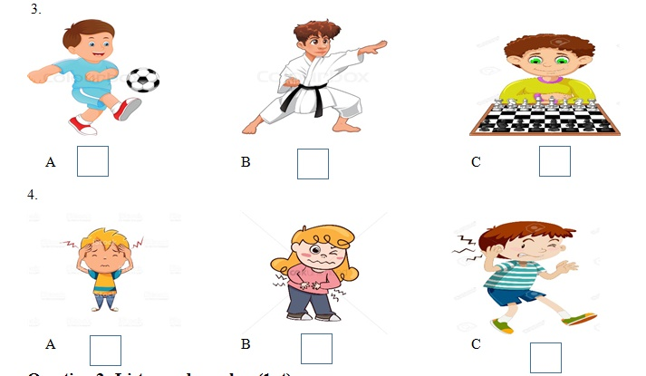
II.Listen and tick A, B or C. There is one example.
EX: | A. It’s chicken.
 | B. It’s milk.
 | C. It’s mineral water.

1. A. I’d like some milk.
B. I like to eat.
C. I’d like some noodles.
2. A. I like to drink.
B. I’d like some lemonade.
C. I’d like some chicken.
3. A. Three.
B. Three, please.
C. Three glasses.
4. A. Two grams.
B. Two pieces.
C. Two glasses.
5. A. Three bowls.
B. Three glasses.
C. Three bottles.

