UNIT 13
WHAT DO YOU DO IN YOUR FREE TIME ?
I. Fill in the blank with suitable word
1. What do you__________in your ______time ? I __________ cartoons on TV.
2. What ___ you doing? – I’m __________chess.
3. Do you like________ sport programmes? – No, I ______. I like _________books.
4. His mother_______________shopping _____weekends.
5. My friends often______ karate in the evening.
II. Listen and tick the correct pictures. There is one example.
Example:
What does she do in her free time?
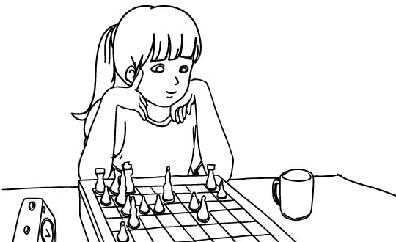 | 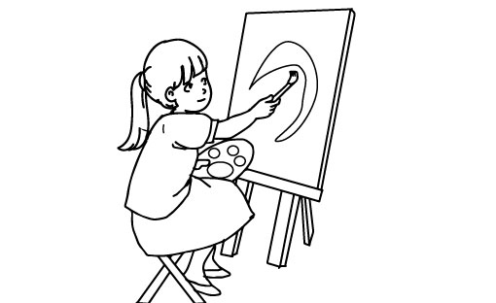 | 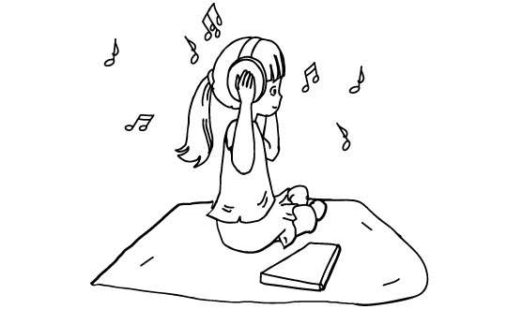
A. | B. | C.
1. What does he do in his free time?
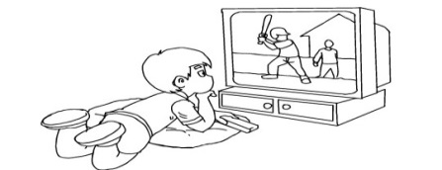  A. | 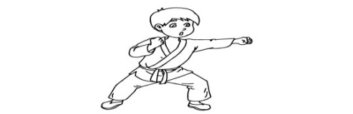  B. | 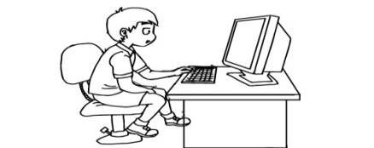  C.

2. What does his father often do in his free time?

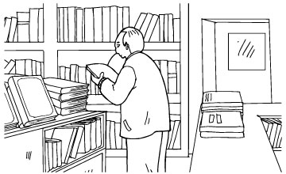  A. | 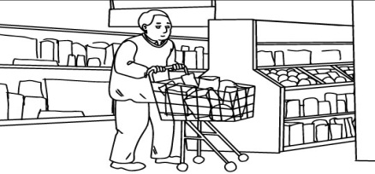  B. | 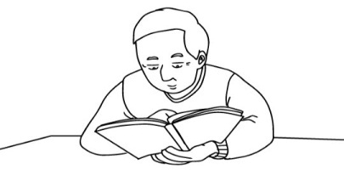  C.

3. What do they often do at the English club?

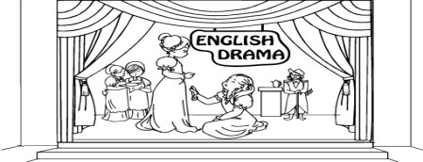  A. | 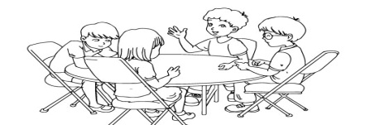  B. | 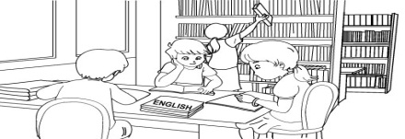  C.

4. What does Lan do in her free time?

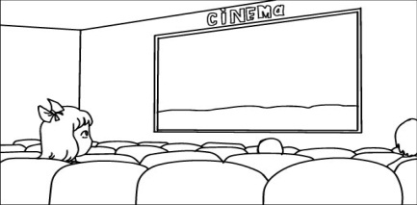  A. | 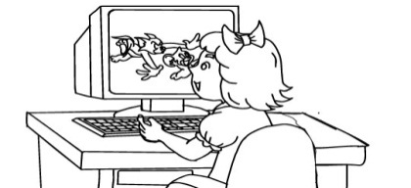  B. | 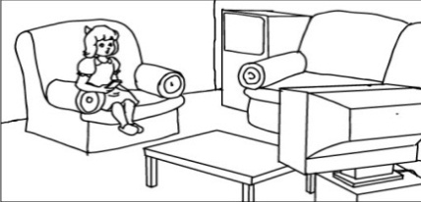  C.

5. What’s his favourite programme?

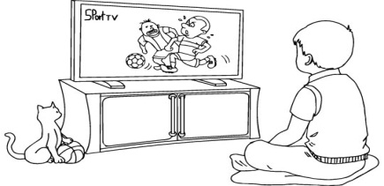  A. | 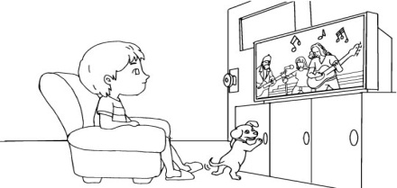  B. | 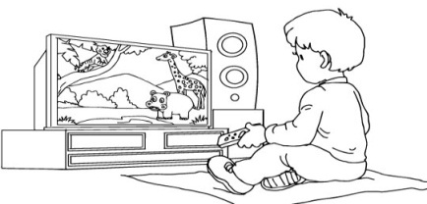  C.

