REVIEW SHEET FOR UNIT 8- FILMS
I. VOCABULARY
1. Pronunciation: How to distinguish the pronounciation of V- ended with “ed”
- Distinguish between two sound: /t/ , /d/ and /id/:
/t/ ( ending sound is voiceless) | /d/ ( ending sound is voiced) | /id/ ( ending sound is  /t/ , /d/ )
Stopped, helped, looked, sentenced, washed…. | Robbed, hugged, loved, closed,….. | Wanted, needed, translated, lifted …

2. Vocabulary:
a. Types of films (Nouns)
1. action ['æk∫n] phim hành động
2. comedy ['kɔmidi] / phim hài
3. documentary [,dɔkju'mentəri] : phim tài liệu
4.horror ['hɔrə]/ : phim kinh dị ( có yếu tố kể về ma quỷ, các thế lực siêu nhiên)
5. romance [rou'mæns]: phim tình cảm lãng mạn
6. sci-fi ['saifai] ( science fiction ['saiəns'fik∫n]) : phim khoa học viễn tưởng
7. animation [,æni'mei∫n]: phim hoạt hình từ truyện tranh
8. thriller : ['θrilə] phim kinh dị ( kể về 1 câu chuyện li kì, có yếu tố giết người, hoặc 1 tội ác)
b. “ed” and “ing” adjectives:-We can form adjectives by adding “ed” and “ ing” endings to some verbs:
-ed adjective | -ing adjectives
Annoyed  Interested  Disappointed | Annoying  Interesting  Disappointing
-We use –ed adjectives to describe someone’s feeling
Eg: The film was long and I was bored.
-We use “-ing adjectives” to describe things or people
Eg: The film was long and boring
II. GRAMMAR:
1.Connectors: Although, despite, in spite of
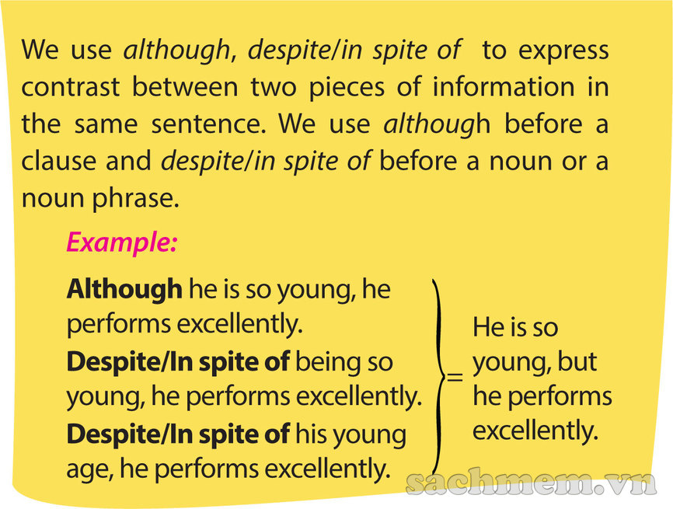

2. However/ Nevertheless ( same meaning/ same use)
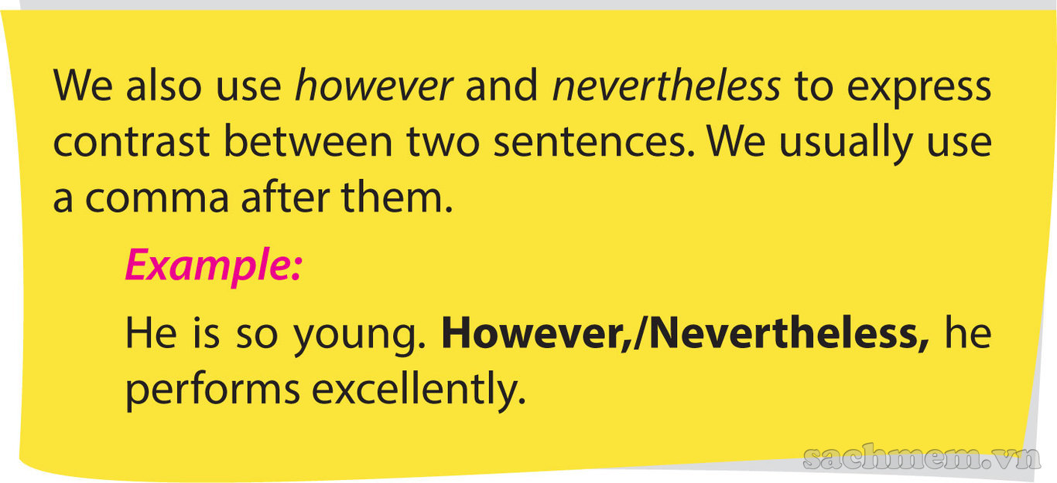
III. EVERYDAY ENGLISH:
1. A: Why don’t we see “ Fury” ?
B: Sounds great!.
2. A: What shall we do?
B: Let’s have lunch at the canteen.

TEST FOR UNIT 8
I/ Find the word which has a different sound in the part underlined.
1 | A. wanted | B. needed | C. laughed | D. liffted
2 | A. stopped | B. laughed | C. looked | D. played
3 | A. allowed | B. translated | C. collected | D. supported
4 | A. sentenced | B. washed | C. lived | D. watched
5 | A. landed | B. wished | C. punted | D. rented
6 | A. agreed | B. packed | C. typed | D. worked
7 | A. liked | B. pleased | C. washed | D. hoped
8 | A. robbed | B. hugged | C. wanted | D. loved
9 | A. kissed | B. closed | C. changed | D. roughed
10 | A. breathed | B. climbed | C. needed | D. mentioned
II/ Choose the best answer A, B, C or D to complete the sentences.
11. | I found the book so ________ that I couldn't put it down.
 | A. tiring | B. shocking | C. gripping | D. boring
12. | Not many people went to see the film; ________ , it received good reviews from critics.
 | A. however | B. but | C. despite | D. although
13. | A ________ is a film that tries to make audiences laugh.
 | A. comedy | B. documentary | C. sci-fi | D. horror
14. | All critics said that film was really ________ ; nevertheless, I was so ________ that I saw it from beginning to end.
 | A. boring – interesting |  | B. interesting - boring
 | C. boring – interested |  | D. interested - bored
15. | ________ having a happy ending, the film starts with a terrible accident.
 | A. Despite | B. However | C. Nevertheless | D. Although
16. | Cameron Diaz and Julia Roberts are the best-paid actresses - both ________ $20 million for their last films.
 | A. took | B. earned | C. did | D. paid
17. | A ________ is a film that shows real life events or stories.
 | A. action | B. comedy | C. documentary | D. thriller
18. | ________ they spent a lot of money on the film, it wasn't a big success.
 | A. Nevertheless | B. However | C. When | D. Although
19. | Who is going to ________ the Oscar for Best Actor this year?
 | A. pass | B. take | C. get | D. win
20. | We were ________ with the latest film of that director.
 | A. satisfied | B. satisfactory | C. satisfy | D. satisfying
21. | The end of the film was so ________ that many people cried.
 | A. exciting | B. moving | C. boring | D. shocking
22. | Last night, I didn't go to bed early ________ being very tired.
 | A. in spite of | B. because of | C. although | D. despite of
23. | The film Titanic was the most successful - it ________ $1,750 million and ________ eleven Oscars.
 | A. got – did | B. made – won | C. did – got | D. won - made
24. | Mr. Bean's Holiday is a ________ film - I was laughing from beginning to end.
 | A. moving | B. hilarious | C. violent | D. scary
25. | They spent a huge amount of money on the film; ________ , it was not a big success.
 | A. however | B. because | C. but | D. although
IV/ Identify the mistake in each sentence:
26. | When Barbara was in Italy, she was used to stay with an Italian family.  A B C D
27. | Although being the best qualified candidate, he didn’t get the job.  A B C D
28. | I rarely see a film in spite of there are many films that are worth seeing.  A B C D
29. | John didn’t went to work because he was seriously ill.  A B C D
30. | The job is badly paid but I’m looking for another one.  A B C D
V. Read the text, choose true, false or no information.
Have you ever read Alice In Wonderland, by Lewis Carol? I did and I really like it. It’s an adventure story full of magic and danger. Yesterday I saw Tim Burton’s version of the film at the cinema.
This story is about Alice, who is now a teenager. A man wants to marry her, but she runs away and falls down a rabbit hole. She travels to Wonderland, which she has visited before as a child, and meets a lot of amazing characters on her adventures.
There are a lot of good special effects in the film. The Red Queen, played by Helena Bonham Carter, is very scary, and Johnny Depp is brilliant as the Mad Hatter. He has acted in a lot of films before but this is my favourite one. Mia Waslkowska is good as Alice; this is her first big film and I think she’s going to become a big star!
Overall, I think this is a good film for teenagers, but it’s a bit long. You should see it if you like fantasy and adventure, but don’t go if you like romances: it’s not a love story.
Charlie, Manchester, UK
31. | Alice In Wonderland was directed by Lewis Carol.
 | A. False | B. True
32. | The film is both an adventure story and a love story.
 | A. True | B. False
33. | Alice is still in her childhood.
 | A. True | B. False
34. | Alice has never been to Wonderland before.
 | A. False | B. True
35. | She meets a lot of amazing people in Wonderland.
 | A. True | B. False
36. | The special effects in the films are good.
 | A. False | B. True
37. | The Red Queen is very friendly.
 | A. True | B. False
38. | The Mad Hatter is played by Johnny Depp.
 | A. True | B. False
39. | Johnny Depp played his first role in this film.
 | A. True | B. False
40. | The writer of the report thinks that the film is a good film for teenagers.
 | A. False | B. True

VI/ Give the correct form of the adjectives in brackets:
41. | I had never expected to be offered the job. I was really _________ when I was offered it. (amaze)
42. | My younger sister was ________ by that film. (terrify)
43. | The film is so __________ that we couldn’t help crying (move)
44. | I was so _______ that I couldn’t believe it was Tom Cruise who directed that film. (disappoint)
45. | My father is very ________ with my Math examination because of________ the mark. (amaze)
VI. Write the second sentence so that is has the same meaning with the first one:
46. Although Tom was a poor student, he studied very well.
=> In spite of ………………………………
47. Mary decided to go to work although she was sick. (however)
=> …………………………………
48 Although the weather was bad, she went to school on time.
=> Despite ……………………………….
49. My mother asked me to see the doctor although I was fine yesterday. ( nevertheless)
=> ………………………………………..
50. Because there was a big storm, I stayed at home.
=> Because of ………………………………………..

ANSWER KEY- TEST FOR UNIT 8
Question | Answer | Question | Answer | Question | Answer | Question | Answer
1 | C | 11 | C | 21 | B | 31 | B
2 | D | 12 | A | 22 | A | 32 | B
3 | A | 13 | A | 23 | B | 33 | B
4 | C | 14 | C | 24 | B | 34 | B
5 | B | 15 | A | 25 | A | 35 | A
6 | A | 16 | B | 26 | B | 36 | B
7 | B | 17 | C | 27 | A | 37 | B
8 | C | 18 | D | 28 | B | 38 | A
9 | A | 19 | D | 29 | B | 39 | B
10 | C | 20 | A | 30 | C | 40 | B

41. amazed
42. terrified
43. moving
44. disappointed
45. amazed/ amazing

46. Although Tom was a poor student, he studied very well.
=> In spite of being a poor student, Tom studied very well.
47. Mary decided to go to work although she was sick. (however)
=> Mary was sick. However, she decided to go to work.
48 Although the weather was bad, she went to school on time.
=> Despite the bad weather, she went to school on time.
49. My mother asked me to see the doctor although I was fine yesterday. ( nevertheless)
=> I was fine yesterday; nevertheless, my mother asked to see the doctor.
50. Because there was a big storm, I stayed at home.
=> Because of the big storm, I stayed at home.

