Review skills 2:unit 8- E7
I. LISTENING
1. Listen to a traffic report. Tick (✔) the things you can hear. There are two things that do not appear in the report. You will listen TWICE.

______ | downtown
______ | accident
______ | injured people
______ | a mess
______ | highway
______ | country line
______ | freeway
2. Listen to the recording, match the extension phone number with the correct type of information. You will listen TWICE.

Enquiry | Number
1. Which movies are being shown | 9
2. Ticket price for young children | 4
3. Annual ticket fee | 3
4. Buying tickets through the phone | 5
5. Expressing dissatisfaction | 1
II. WRITING
1. Complete the second sentence so that it means the same as the first. Use the word in brackets. You can’t change the word.
Here is an example.
0. The bookshop is opposite the library.
_________________________ a bookshop opposite the library. (THERE)
Answer: 0. There is
1. How about cycling to school with me tomorrow? (CYCLE)
Let’s _________________________________________.
2. What is the meaning of this road sign? (MEAN)
What ___________________________________________?
3. Accident is the main cause of traffic jams in Bangkok. (CAUSED)
Traffic jams in Bangkok ____________________________________________.
4. People will be fined if they don’t obey the traffic rules. (DISOBEY)
People will be fined __________________________________________.
5. I spend 30 minutes walking to school every day. (TAKES)
It _________________________________________.
2. Write a short paragraph (80-100 words) about a film that you like the most. You should use the following cues:
- What film it is
- When you watched it
- What it was about
- Why you like it

Keys: unit 8:Skills 2- E7
I. LISTENING
1. Listen to a traffic report. Tick (✔) the things you can hear. There are two things that do not appear in the report. You will listen TWICE.
✔ | downtown
✔ | accident
______ | injured people
✔ | a mess
✔ | highway
______ | country line
✔ | freeway
Hello. This is Tieng Anh 7. Unit 7. Listening Test.
TASK 1. Listen to a traffic report. Tick (✔) the things you can hear. There are two things that do not appear in the report. You will listen TWICE.

Now, listen and tick.
This is Betty Bellarussa with your 5 pm traffic report. Well, if you're on the roads listening to this, you already know that traffic is pretty much a mess everywhere. On Interstate 7, it crawls from downtown to the country line.
Vehicles crossing the lake on State Route 50 are gridlocked both eastbound and westbound. And the valley freeway is stop-and-go from Mayberry through Winwood. Highway 17 is slow through the city, then clears out until Overpass Road. If that weren't bad enough, an injury accident is blocking Main Street downtown, causing a 15-minute backup for cars waiting to get onto the freeway. This has been Betty Bellarussa with your 5 pm traffic update. Our next traffic report will be at the bottom of the hour.
(Dừng)
Now listen again. (phát lại bài nghe)

2. Listen to the recording, match the extension phone number with the correct type of information. You will listen TWICE.
Key: 1. 1 | 2. 5 | 3. 4 | 4. 9 | 5. 3
TASK 2. Listen to the recording, match the extension phone number with the correct type of information. You will listen TWICE.
Now listen and match.

Thank you for calling the National Movie Centre. We are happy to assist you to get the right type of information.
Please listen carefully and select the option which best suits your need. For enquiry about movies which are currently on, press 1. For enquiry about the price of tickets in different sections, press 2. For enquiry about discounted price ticket for groups of more than twenty people, elderly and young children, press 5. For information regarding purchasing annual or monthly tickets, press 4. For information regarding the cinema’s offers on special occasions, press 6. For booking tickets and paying through the phone, press 9. If you would like to make a complaint about our service, please press 3. For other enquiries, press 0. Thank you.
Dừng)
Now listen again. (phát lại bài nghe)
II. . WRITING
1. Complete the second sentence so that it means the same as the first. Use the word in brackets. You can’t change the word.
1. Let’s cycle to school with me tomorrow.
2. What does this road sign mean?
3. Traffic jams in Bangkok are mainly caused by accidents.
4. People will be fined if they disobey traffic rules.
5. It takes me 30 minutes to walk to school every day.
2. Write a short paragraph (80-100 words) about a film that you like the most. You should use the following cues:
Sample writing:
The movie I like the most is The Mockingjay part 2. It was the last film of the Hunger Game series. I watched it in November 2015 at the National Cinema. I went there with a group of my classmates after we finished an important examination. The movie was about a heroine, Katniss Everdeen, who devoted her own life to save the life of other people in her nation. I like the movie because it was full of heroic actions. The film also showed how friendship and love could overcome all difficulties and challenges. That is a really important lesson for me.

Review skills 1:unit8- E7

I. READING
1. Read the passage and answer the questions with NO MORE THAN FIVE WORDS.
Emma Watson is a British actress, model, and activist. She has been widely known not only as a talented young actress, but also a humanitarian. She rose to fame after having her first professional acting role as Hermione Granger in the Harry Potter film series from 2001 to 2011. Other successes include her acting in The Perks of Being a Wallflower and The Bling Ring. Besides her movie career, she has also earned a bachelor’s degree in English literature. She was appointed the UN Women Goodwill Ambassador in July 2014. At the age of 26, she has dedicated her efforts towards the empowerment of young women and promotion of gender equality worldwide. Emma shared, ‘I still have so much to learn, but as I progress I hope to bring more of my individual knowledge, experience and awareness to this role.’
1. What nationality is Emma Watson?
_______________________________________________________
2. What role turned Emma Watson into a famous actress?
______________________________________________________
3. What is her highest qualification?
______________________________________________________
4. What role has she undertaken since 2014?
______________________________________________________
5. Which gender has Emma promoted development for?
______________________________________________________
2. Read about traffic problems in two cities. Match the city with its problem.
A. Ho Chi Minh City
B. Bangkok
In Ho Chi Minh City, it is not strange to see the sight of a street that is crowded with vehicles. People cannot move and their health is affected by polluted air from exhausted fumes. What are the reasons? The citizens in the city use many personal vehicles to go from one place to another. They aren't used to transporting by public transports. May be because the bus drivers are careless, impolite to them or the taxi fare is too high for some people.
Bangkok is world renowned for its terrible traffic problems, so getting around on the roads is a bit of a nightmare. In my opinion, there are 3 main causes of Bangkok traffic jams. First, the quality of public transportation is low. Bus is of low quality and causes congestion. Second, the BTS and MRT are not enough for users. Finally, the most important cause of traffic jam is car accidents. Bad bus drivers cause accidents frequently and make the road stuck for hours.
PROBLEMS
1. It has low quality public transport.
2. It costs a lot to go by taxi.
3. There are not enough MRTs for its inhabitants.
4. Its citizens use a lot of personal vehicles.
5. There is a high frequency of accidents.
I. SPEAKING
1. Now I’m going to ask you FOUR questions about traffic in Viet Nam. Are you ready?
1. How do most people in Viet Nam travel within the country?
2. How do most people in Viet Nam travel to and from work?
3. Is there any traffic problem in Viet Nam. What is it?
4. Can you suggest a way you think can improve the traffic situation in Viet Nam? Why?/Why not?
2. Each of you will now receive a card. On the card there is a picture and clues for five questions. You should use the words to make questions and ask your friend. Your friend will answer the questions based on the picture he/she has.
CARD A
Use the words given below to make questions. Ask your friend about his/her picture and listen to the answers.
1. What/see/picture/?
2. How/look/?
3. Where/they/?
4. What/happen/?
5. What/you/do/?/Why/?
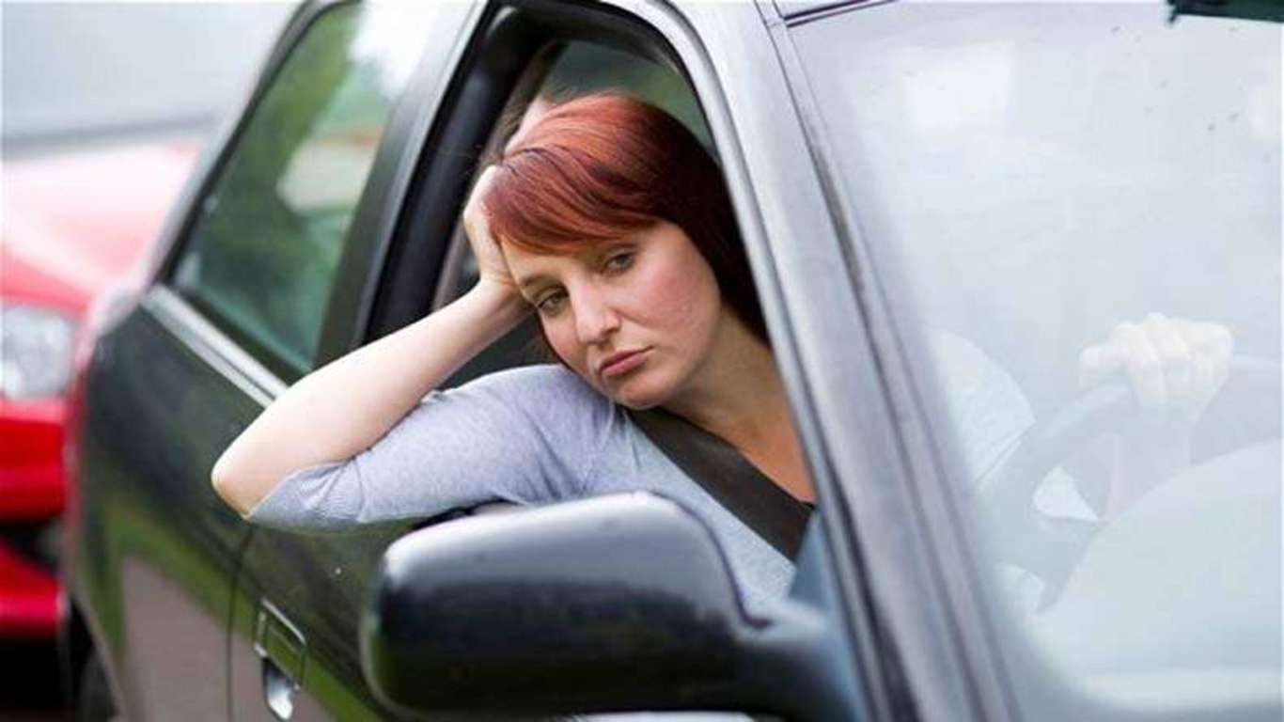
Now, your friend will ask you questions about your picture. Answer his/her questions.
CARD B
Use the words given below to make questions. Ask your friends about his/her picture and listen to the answers.
1. What/see/picture/?
2. Where/they/?
3. What/they/do/?
4. What/happen/?
5. What/you/do/?/Why/?Now, your friend will ask you questions about your picture. Answer his/her questions.
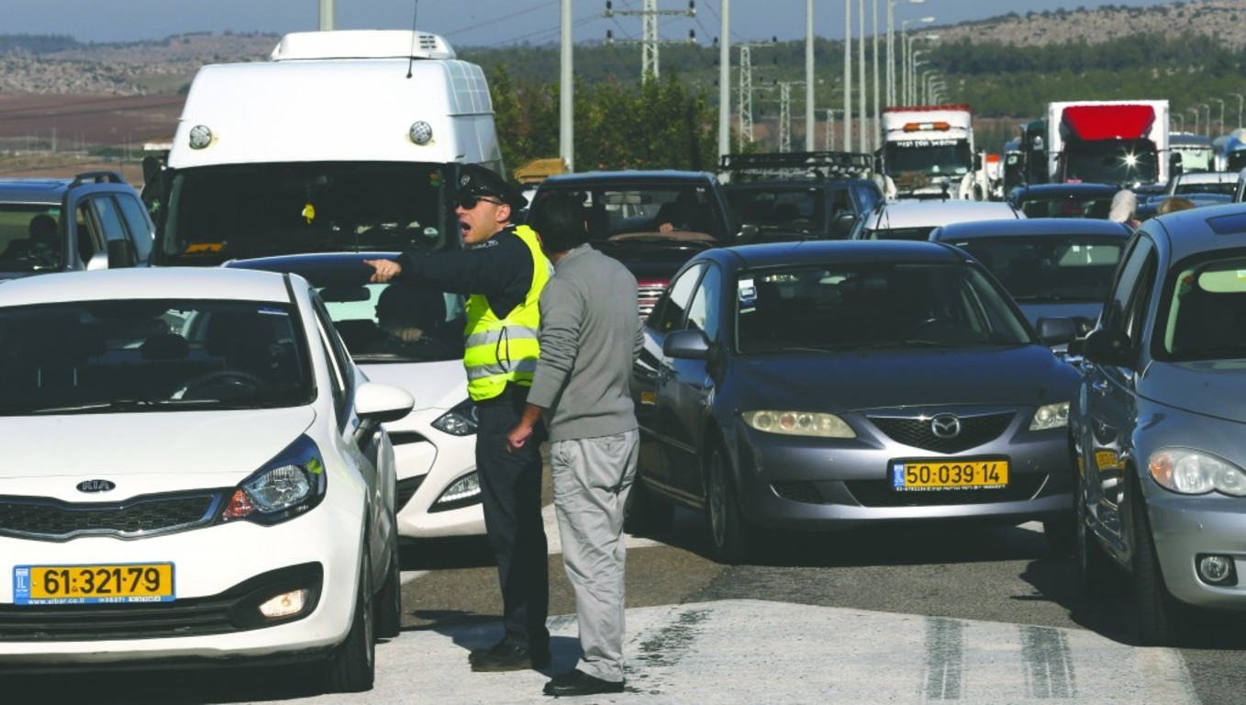
-- The end --
Key: Review skills 1:unit 8 E7
I. READING
1. Read the passage and answer the questions with NO MORE THAN FIVE WORDS.
1. British
2. Hermione Granger
3. Bachelor’s degree (in English literature)
4. (The) UN Women Goodwill Ambassador
5. women/female
2. Read the passage and decide whether the statements are true (T) or false (F). Circle T or F.
1. F | 2. F | 3. T | 4. T | 5. F
II. WRITING
1. Complete the second sentence so that it means the same as the first. Use the word in brackets. You can’t change the word.
1. Let’s cycle to school with me tomorrow.
2. What does this road sign mean?
3. Traffic jams in Bangkok are mainly caused by accidents.
4. People will be fined if they disobey traffic rules.
5. It takes me 30 minutes to walk to school every day.
2. Write a short paragraph (80-100 words) about a film that you like the most. You should use the following cues:
Sample writing:
The movie I like the most is The Mockingjay part 2. It was the last film of the Hunger Game series. I watched it in November 2015 at the National Cinema. I went there with a group of my classmates after we finished an important examination. The movie was about a heroine, Katniss Everdeen, who devoted her own life to save the life of other people in her nation. I like the movie because it was full of heroic actions. The film also showed how friendship and love could overcome all difficulties and challenges. That is a really important lesson for me.
-- The end –

Review LANGUAGE FOCUS :unit 8 E7
1. Choose the word whose underlined part is pronounced differently from the others’. Circle A, B, C, or D.
1. A. liked | B. hated | C. acted
2. A. starred | B. showed | C. watched
3. A. decided | B. reviewed | C. suggested
4. A. featured | B. enjoyed | C. attended
5. A. disliked | B. received | C. argued
2. Choose the best option to complete each sentence. Circle A or B.

1. I am really ___________ with how this drama ended.

A. annoyed | B. annoying

2. Many people couldn’t understand the ending of the movie. It’s so ___________.

A. confused | B. confusing

3. It’s such a ___________ scene, blood’s coming from everywhere!

A. frightened | B. frightening

4. Some critics ranked ‘Fantastic Four’ as one of the most ___________ movies in 2015.

A. disappointed | B. disappointing

5. The National Cinema has managed to make the audience feel more ___________ with its service.

A. satisfied | B. satisfying
3. Match the words on the left with their definitions on the right.
Words | Definition
1. section | A. a person in a novel, play or film
2. character | B. the main events of a play, novel or film
3. review | C. a person who gives an opinion of something
4. plot | D. an assessment or evaluation of something
5. critic | E. a part of something
-- The end –

Key:Review LANGUAGE FOCUS :unit 8 E7
I. LANGUAGE FOCUS
1. Choose the word whose underlined part is pronounced differently from the others’. Circle A, B, C, or D.
1. A | 2. C | 3. B | 4. C | 5. A
2. Choose the best option to complete each sentence. Circle A or B.
1. A | 2. B | 3. B | 4. B | 5. A
3. Match the words on the left with their definitions on the right.
1. E | 2. A | 3. D | 4. B | 5. C

